**Spring Core and Maven**

**Exercise 1: Configuring a Basic Spring Application**

**CODE:**

**pom.xml**

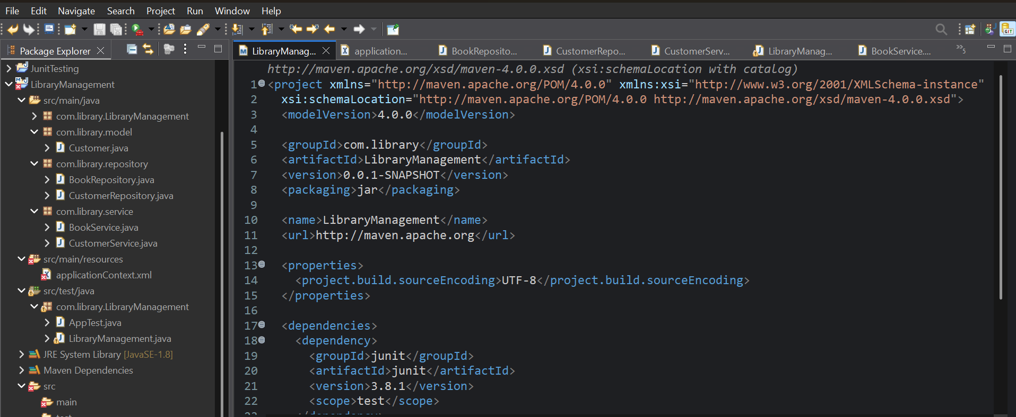 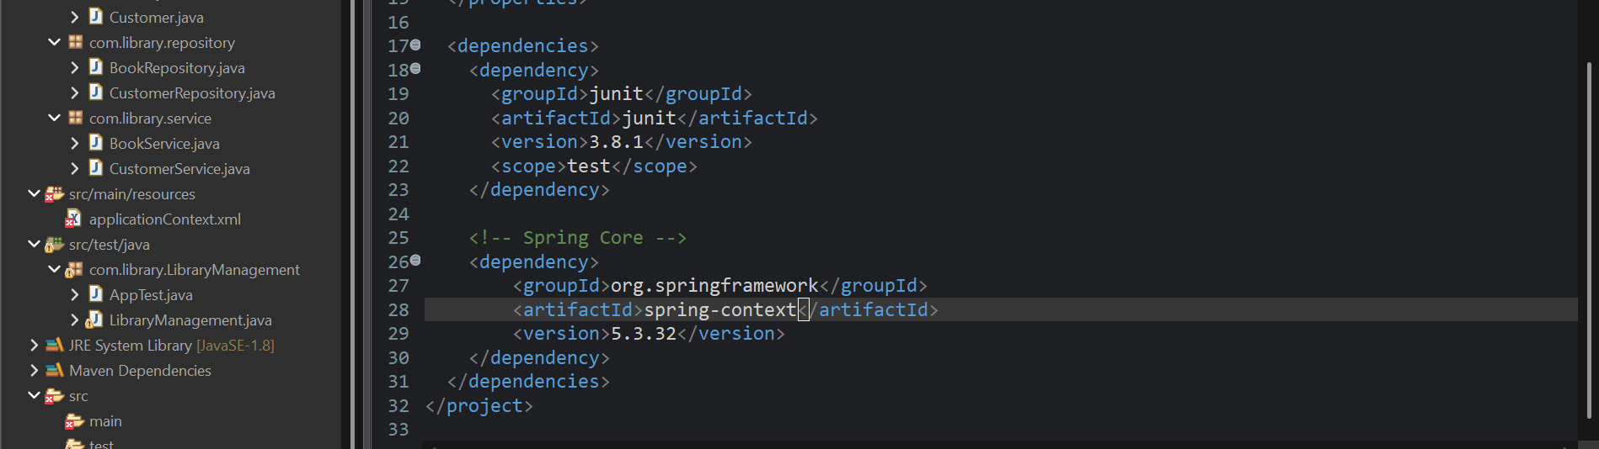

**applicationContext.xml**

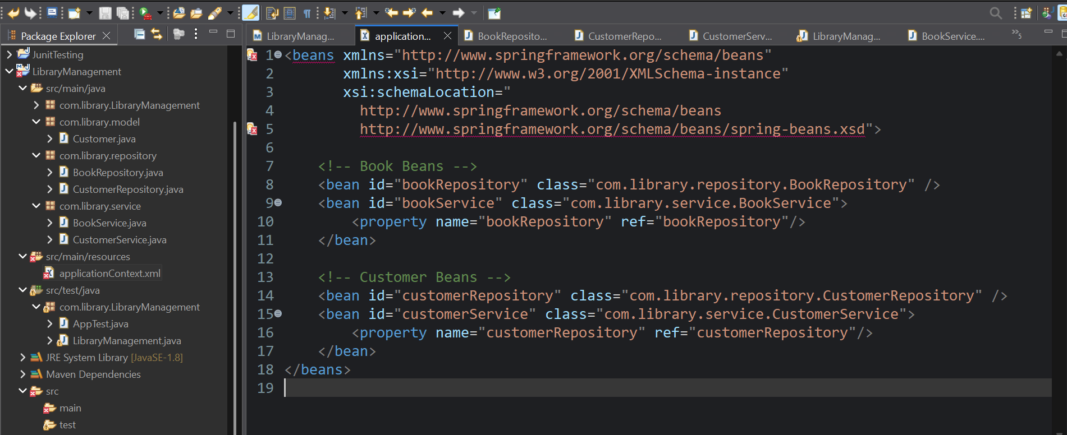

**BookService.java**

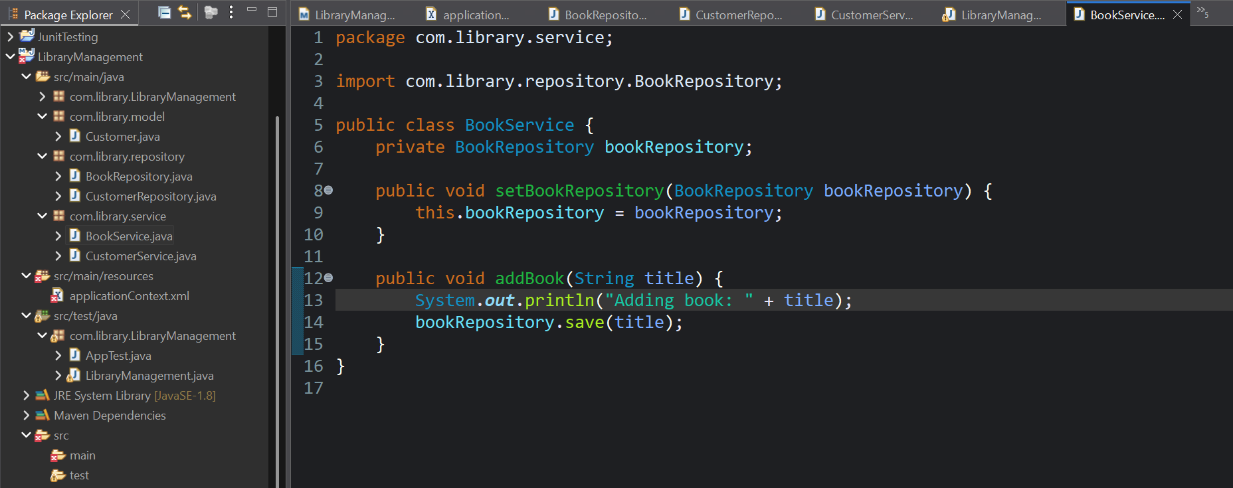

**BookRepository.java**

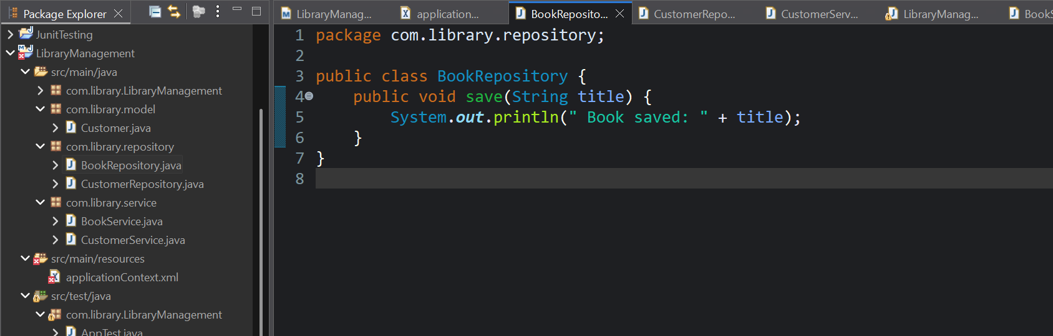

**Customer.java**

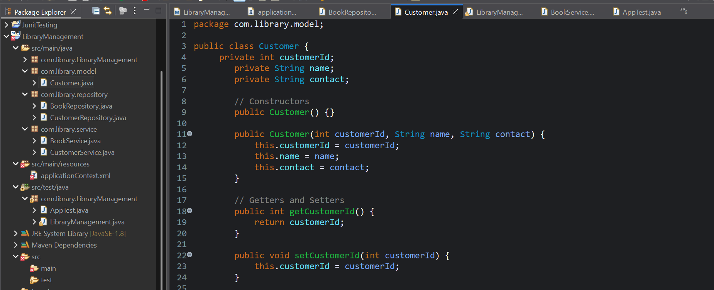

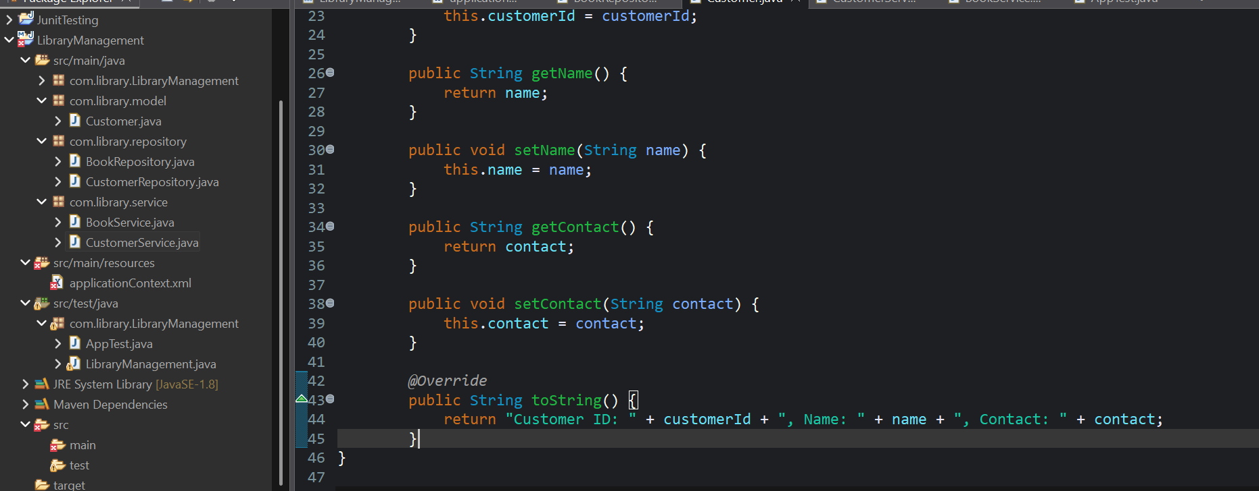

**CustomerService.java**

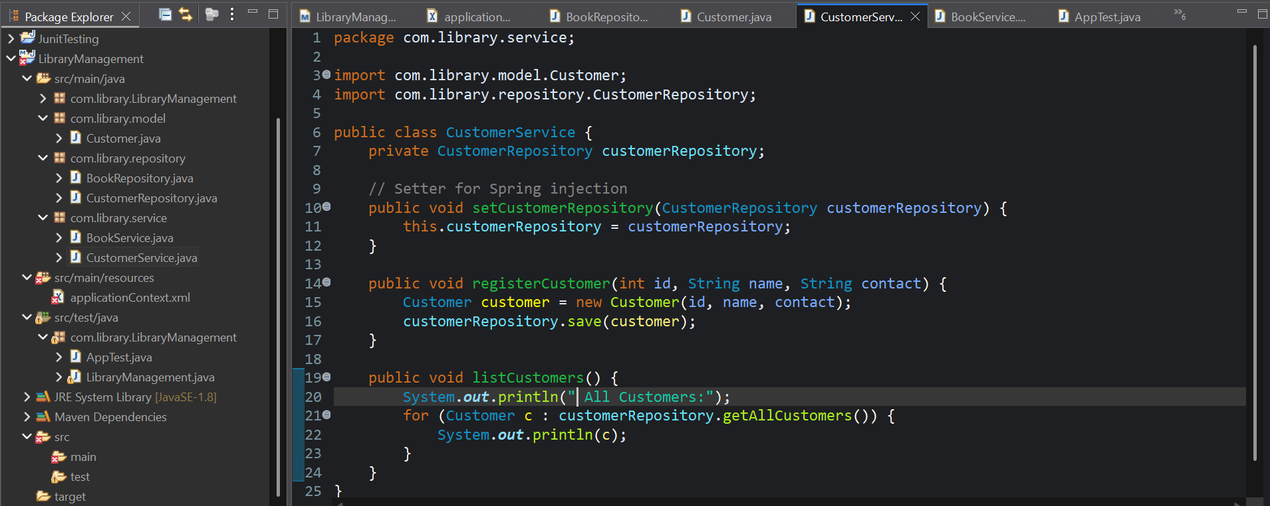

**CustomerRepository.java**

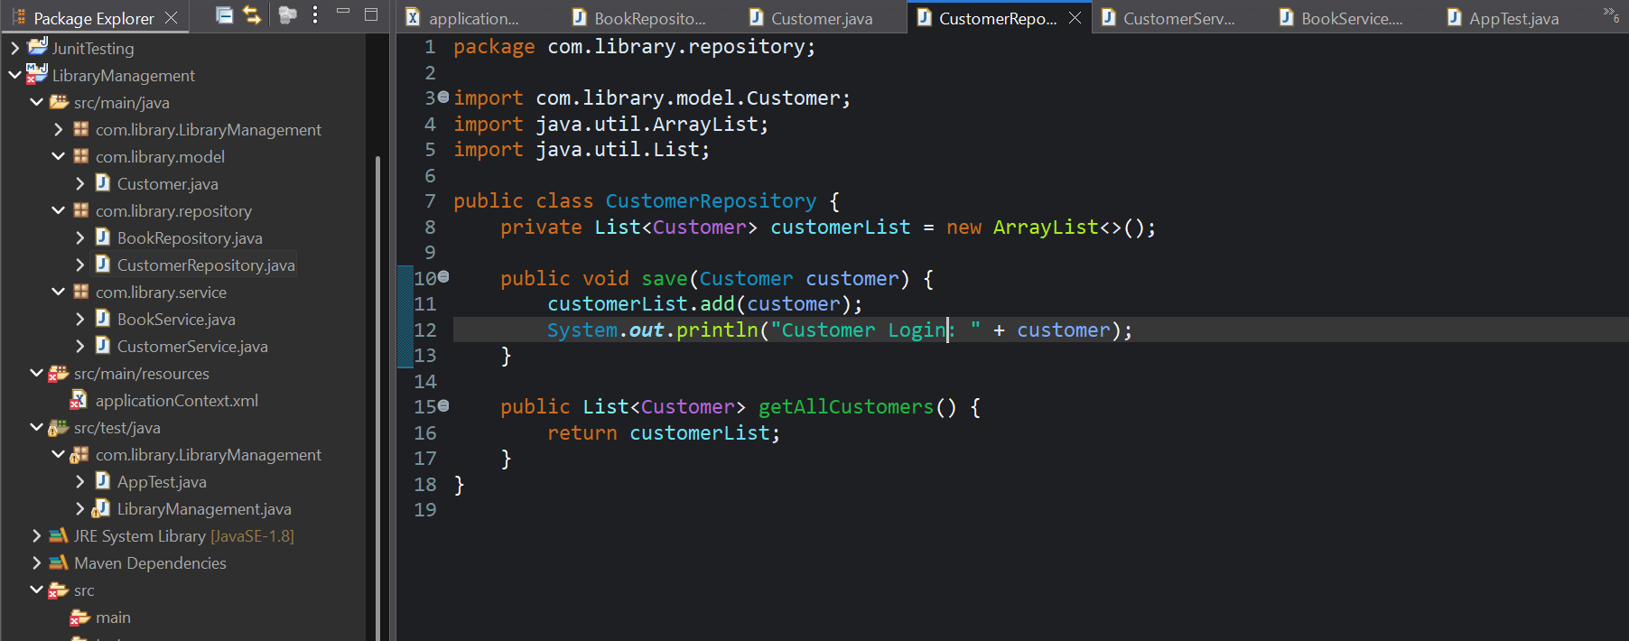

**LibraryManagement.java**

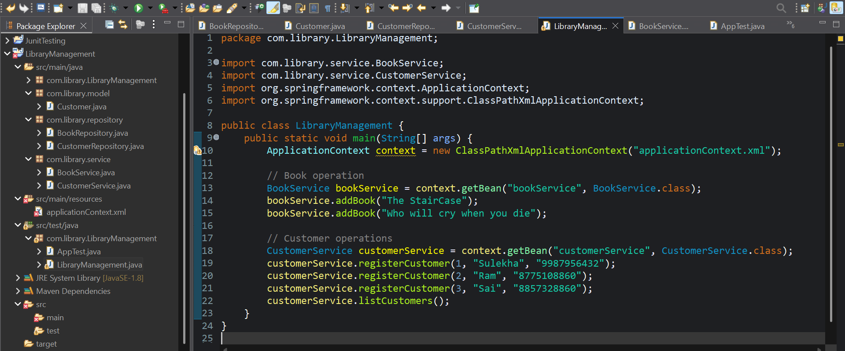

**OUTPUT:**

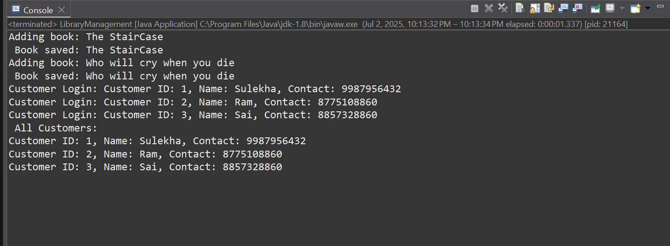

**Exercise 2: Implementing Dependency Injection**

**CODE:**

**pom.xml**

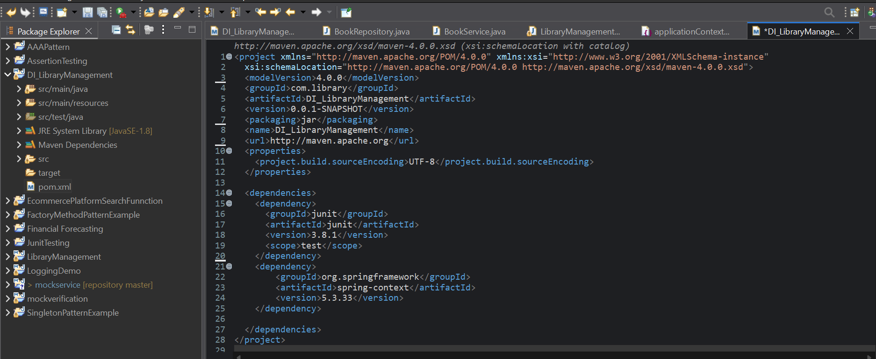

**applicationContext.xml**

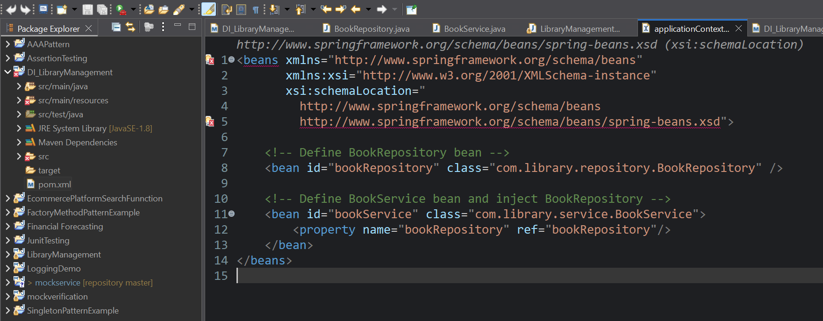

**BookService.java**

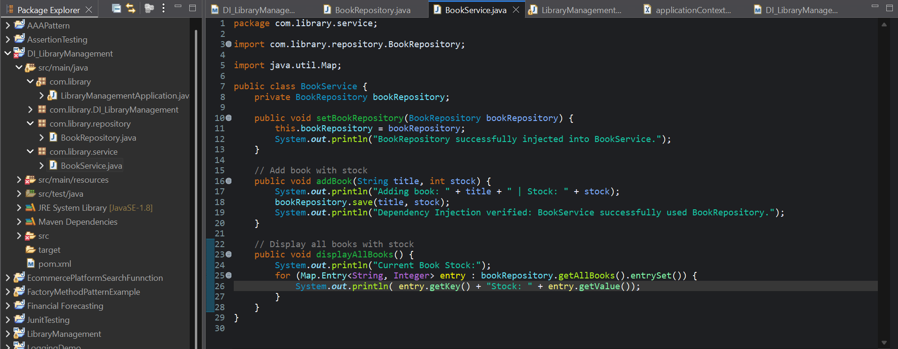

**BookRepository.java**

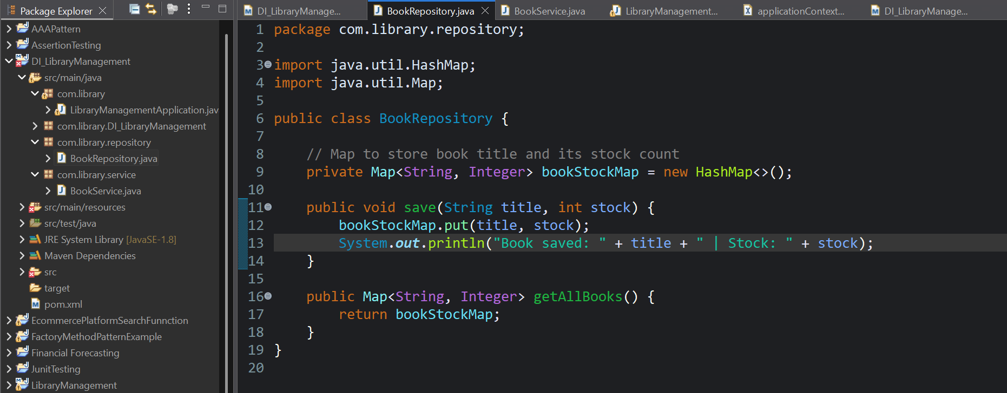

**LibraryManagementApplication.java**

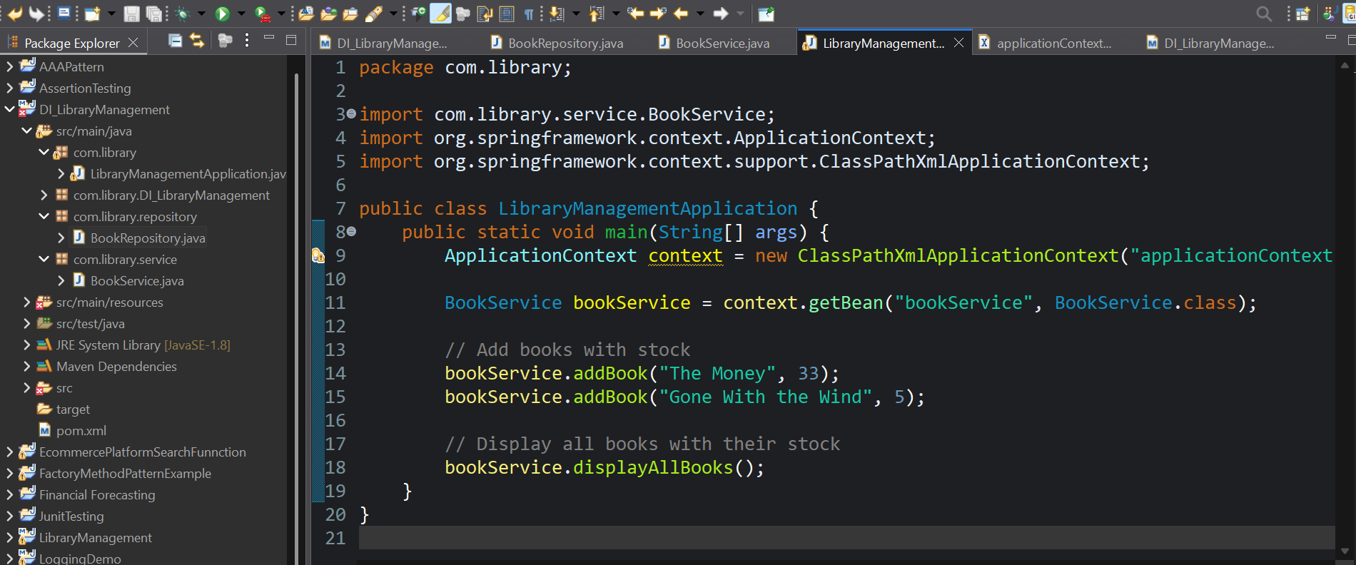

**OUTPUT:**

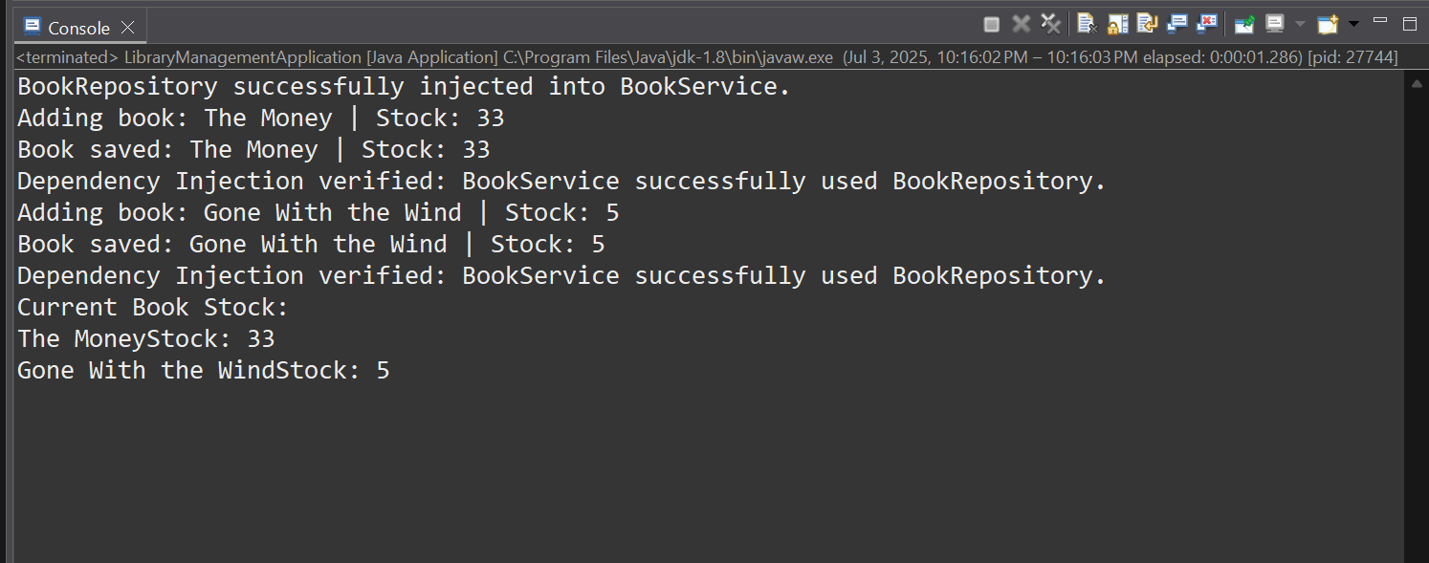

**Exercise 4: Creating and Configuring a Maven Project**

**CODE:**

**pom.xml**

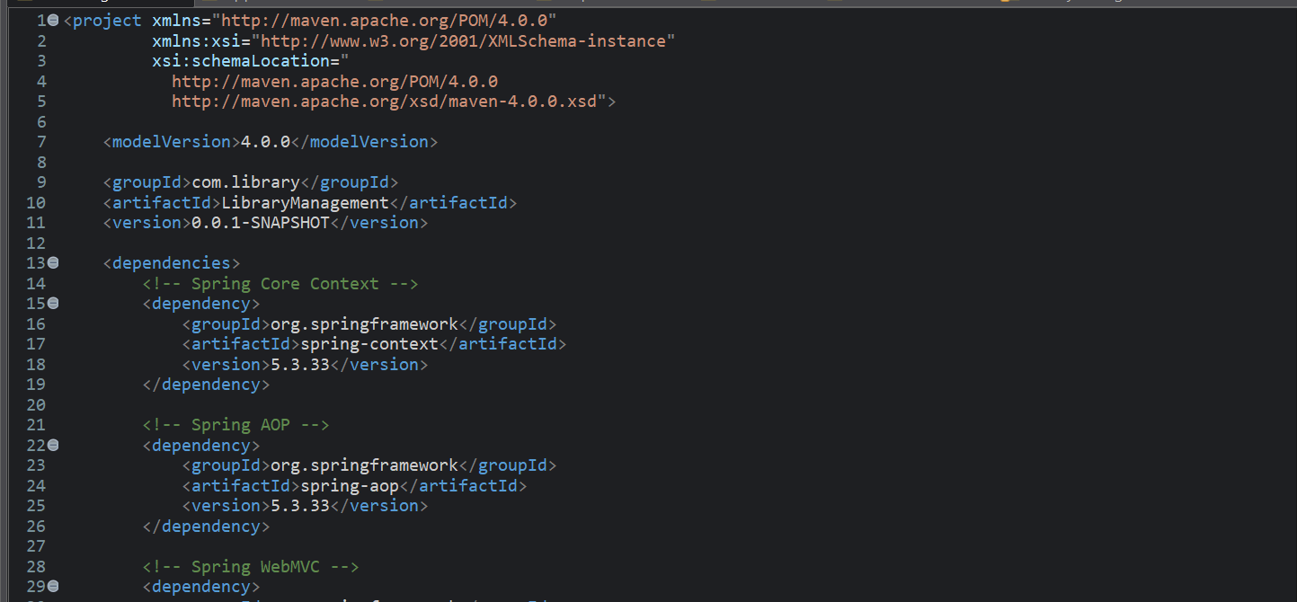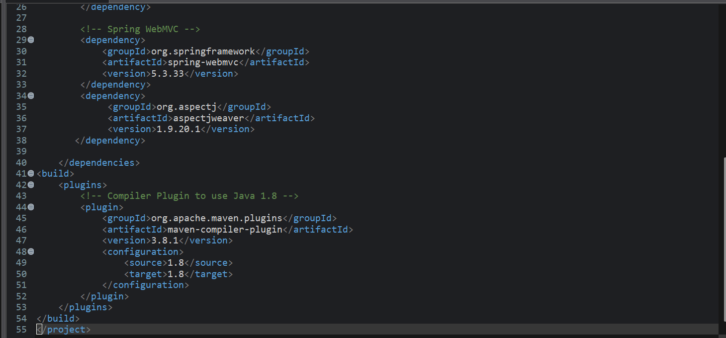

**applicationContext.xml**

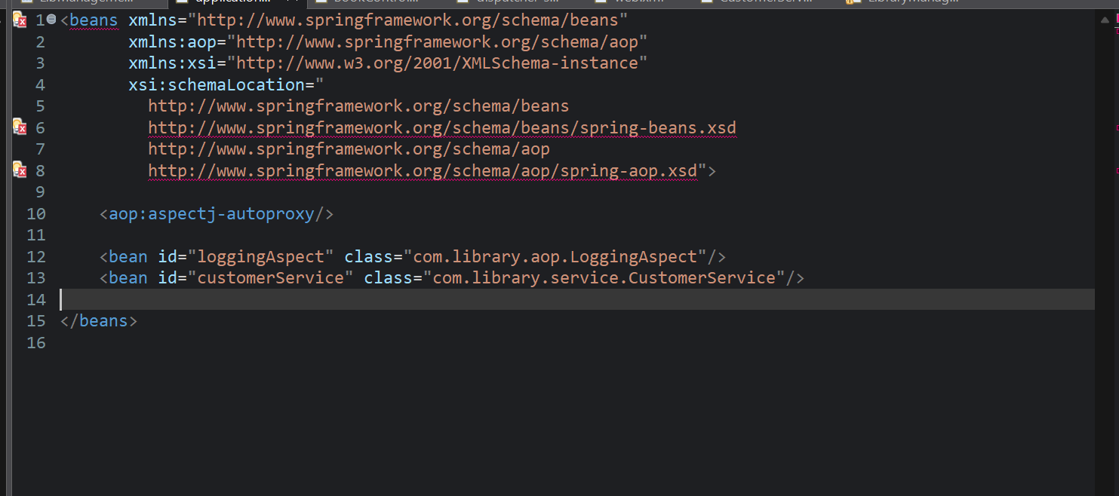

**Dispatcher-servlet.xml:**

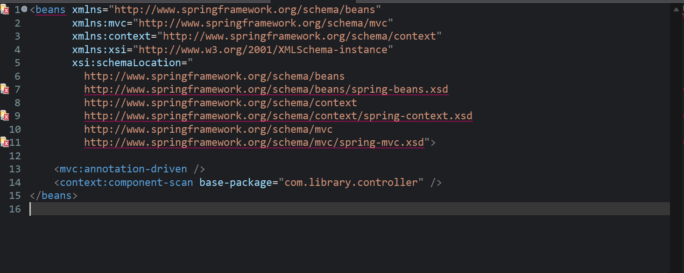

**Web.xml:**

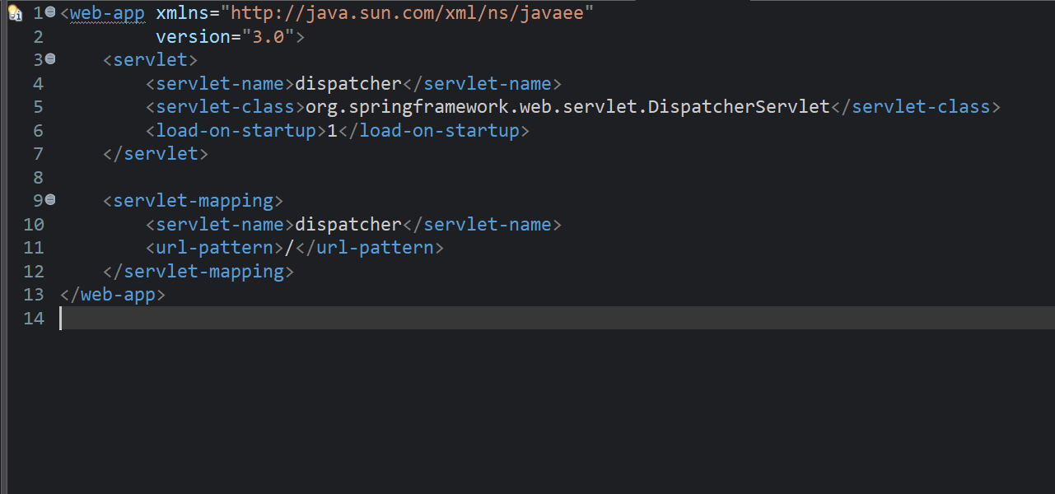

**LoggingAspect.java:**

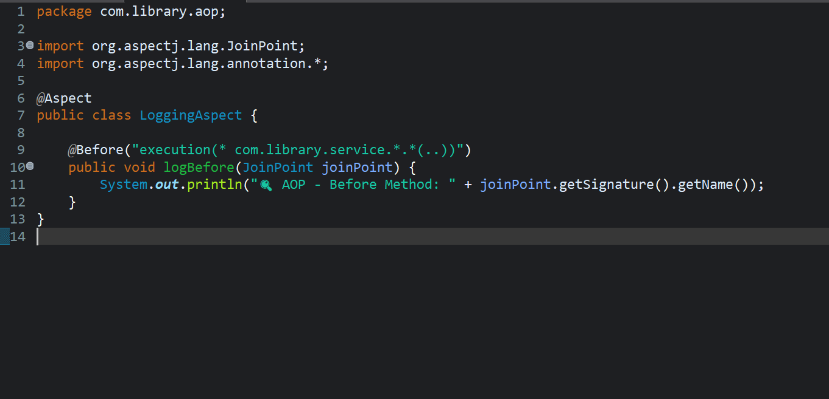

**CustomerService.java:**

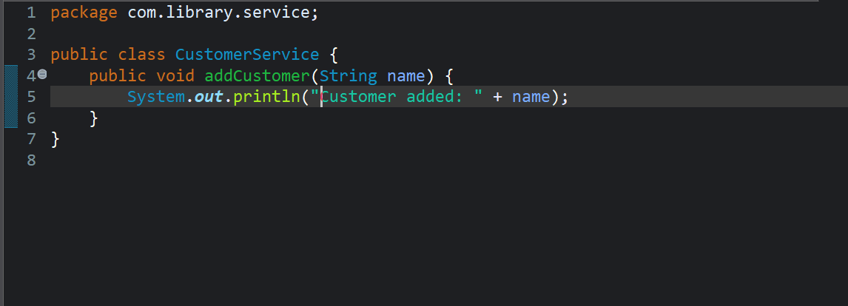

**LibraryManagementApplication.java:**

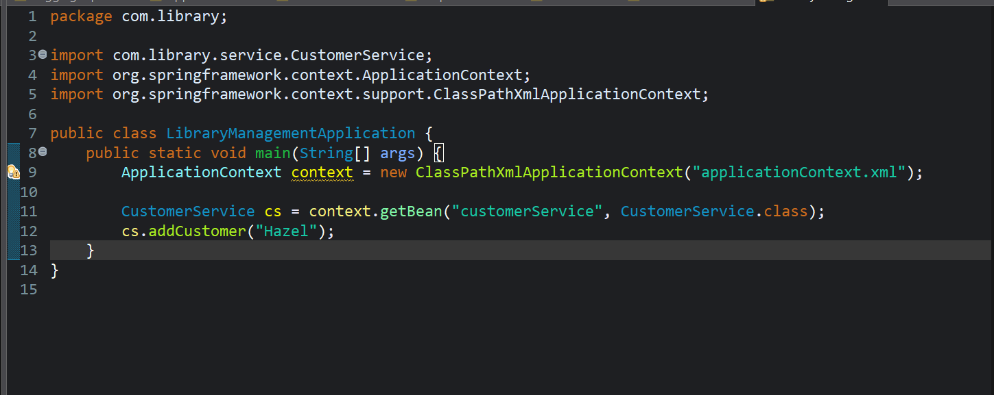

**OUTPUT:**

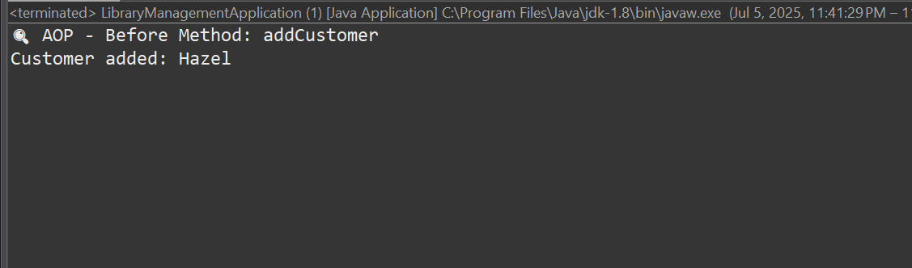

**Exercise 5: Configuring the Spring IoC Container**

**CODE:**

**pom.xml**

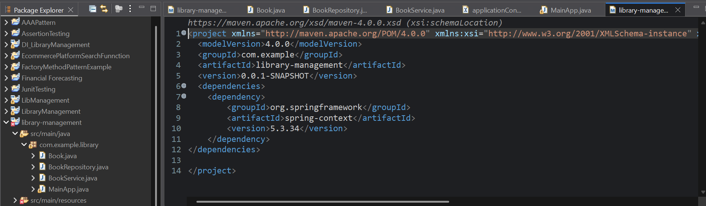

**applicationContext.xml**

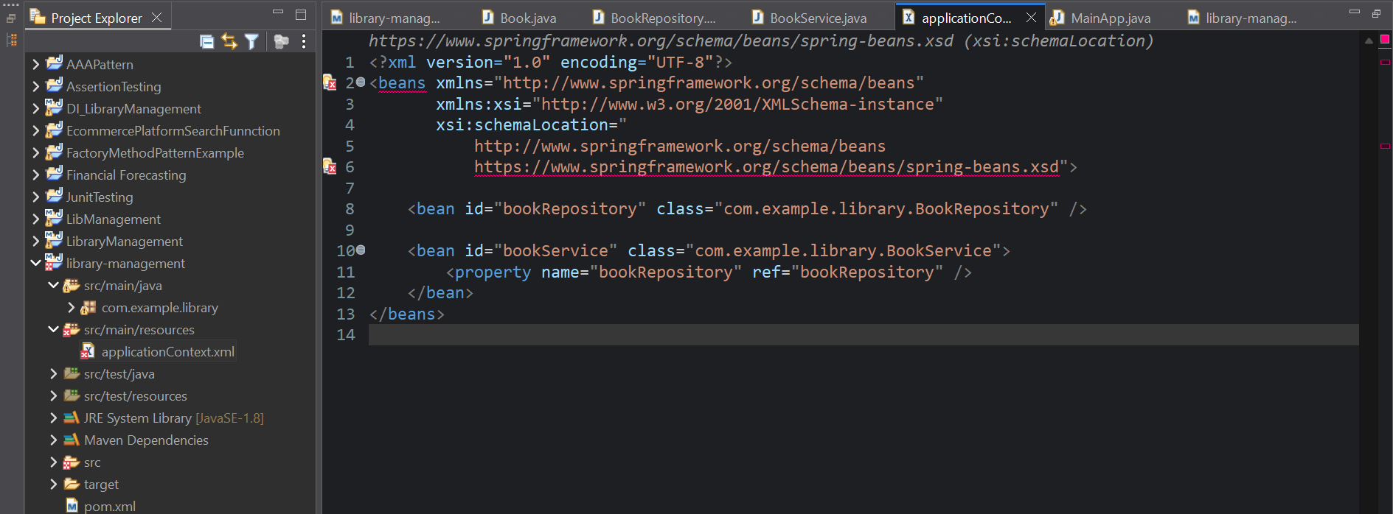

**Book.java**

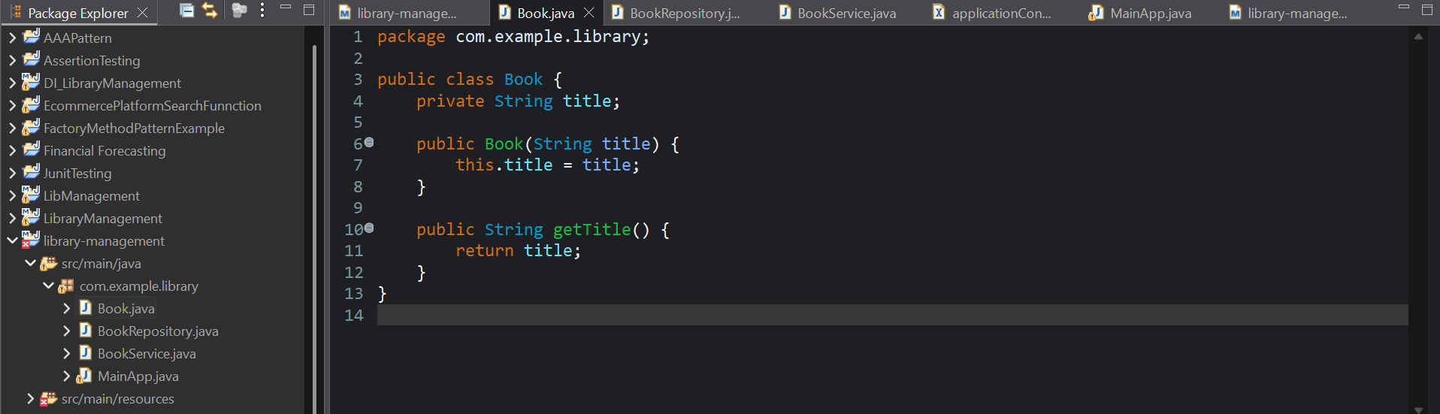

**BookRepository.java**

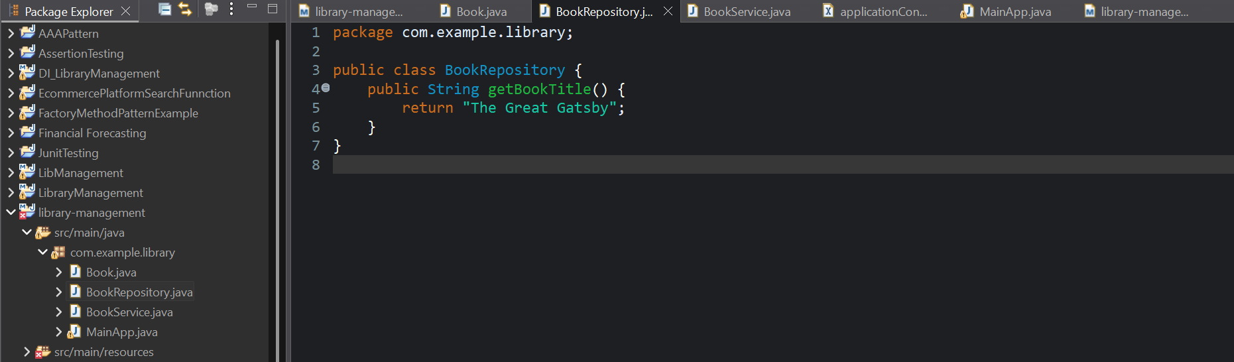

**BookService.java**

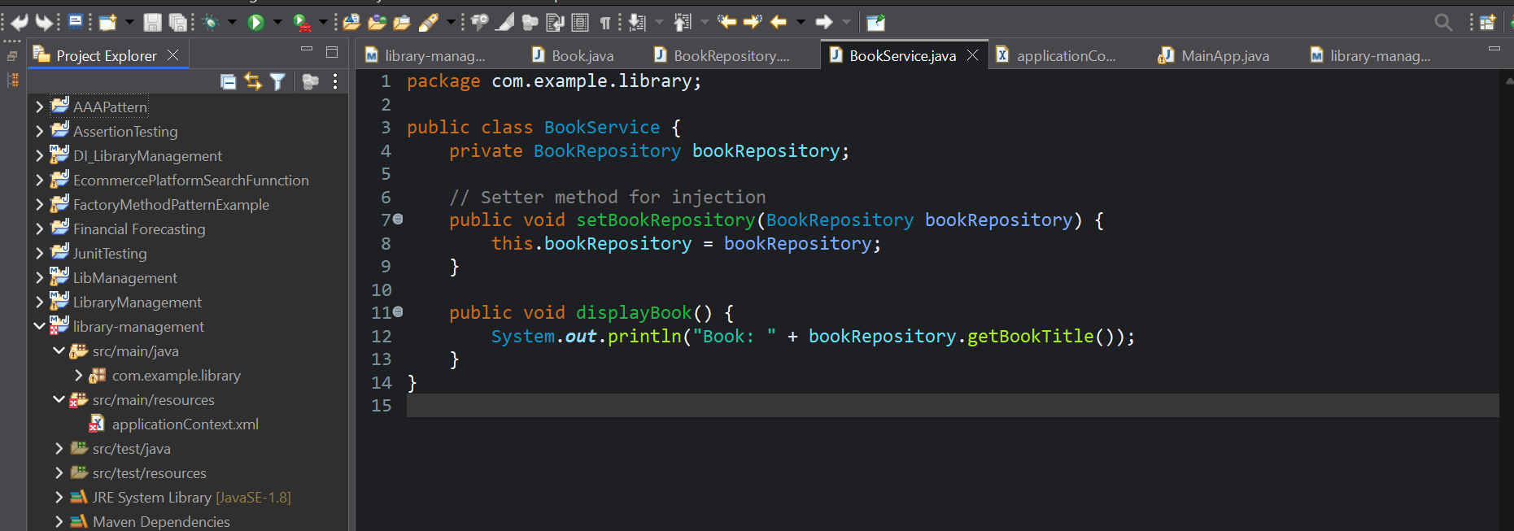

**MainApp.java**



**OUTPUT:**

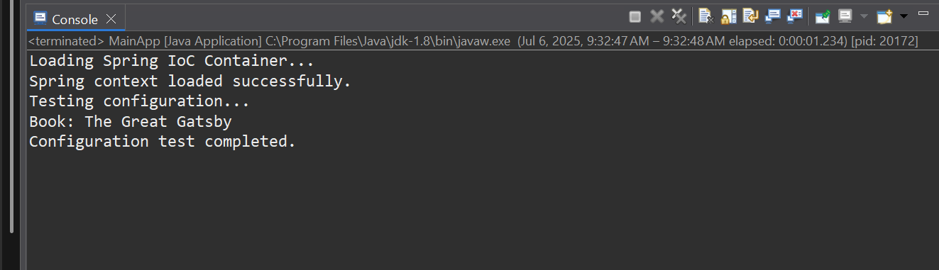

**Exercise 7: Implementing Constructor and Setter Injection**

**CODE:**

**pom.xml**



**applicationContext.xml**

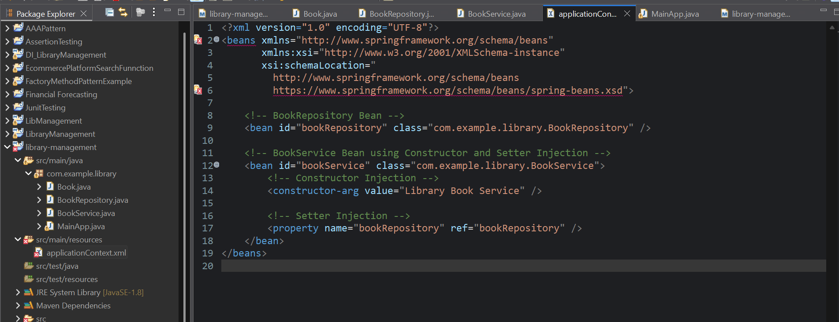

**Book.java**



**BookRepository.java**



**BookService.java**



**MainApp.java**

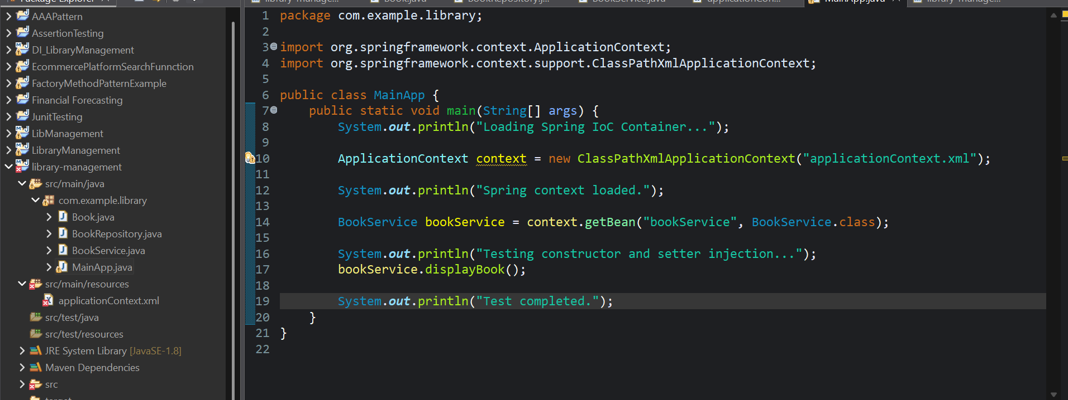

**OUTPUT:**

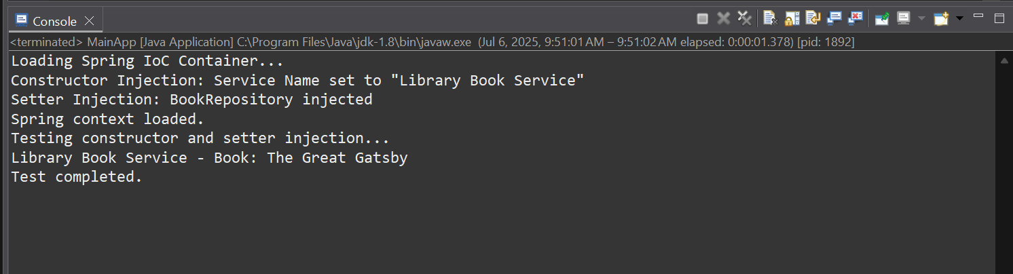

**Exercise 9: Creating a Spring Boot Application**

**CODE:**

**pom.xml**

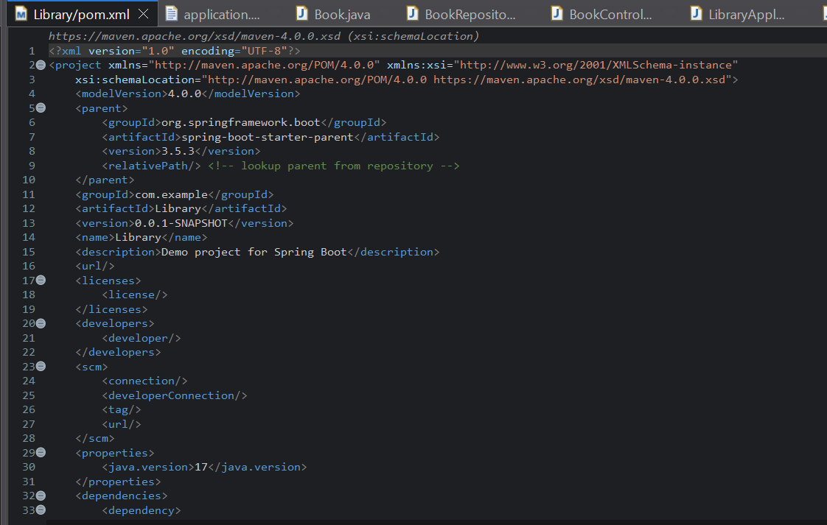 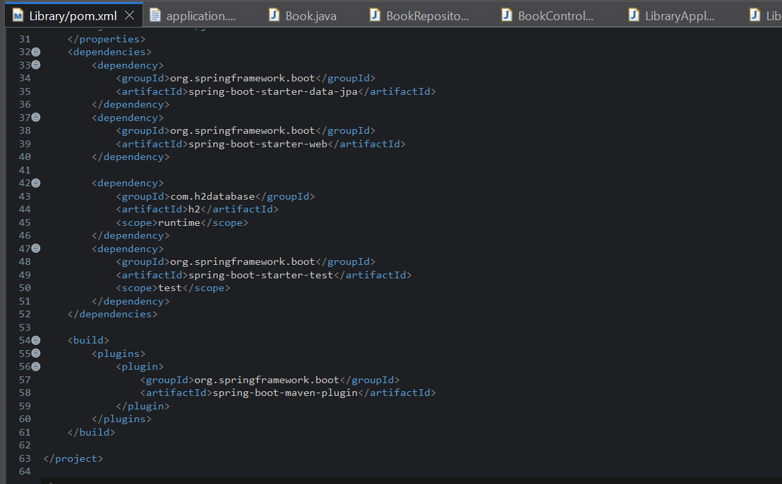

**application.properties**

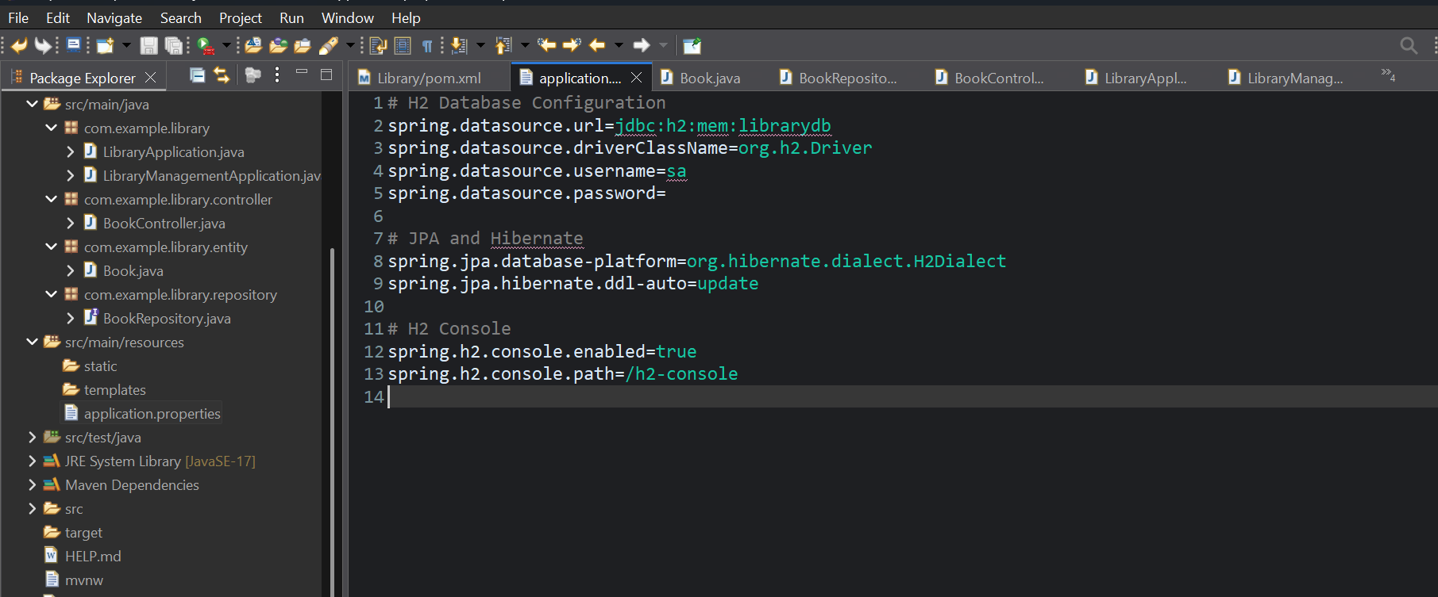

**Book.java**

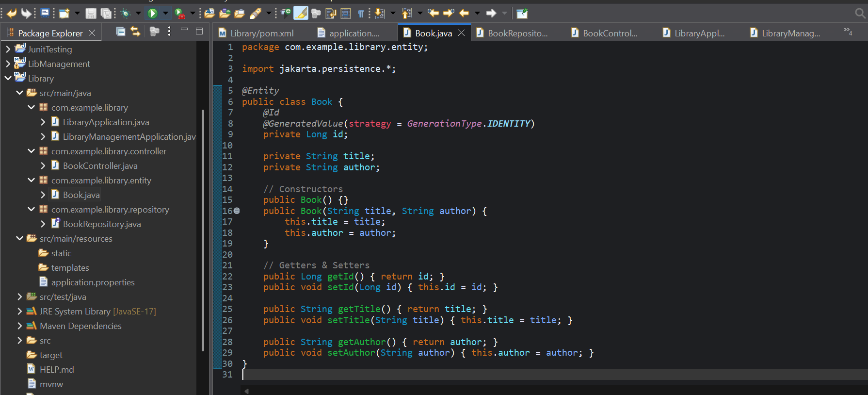

**BookRepository.java**

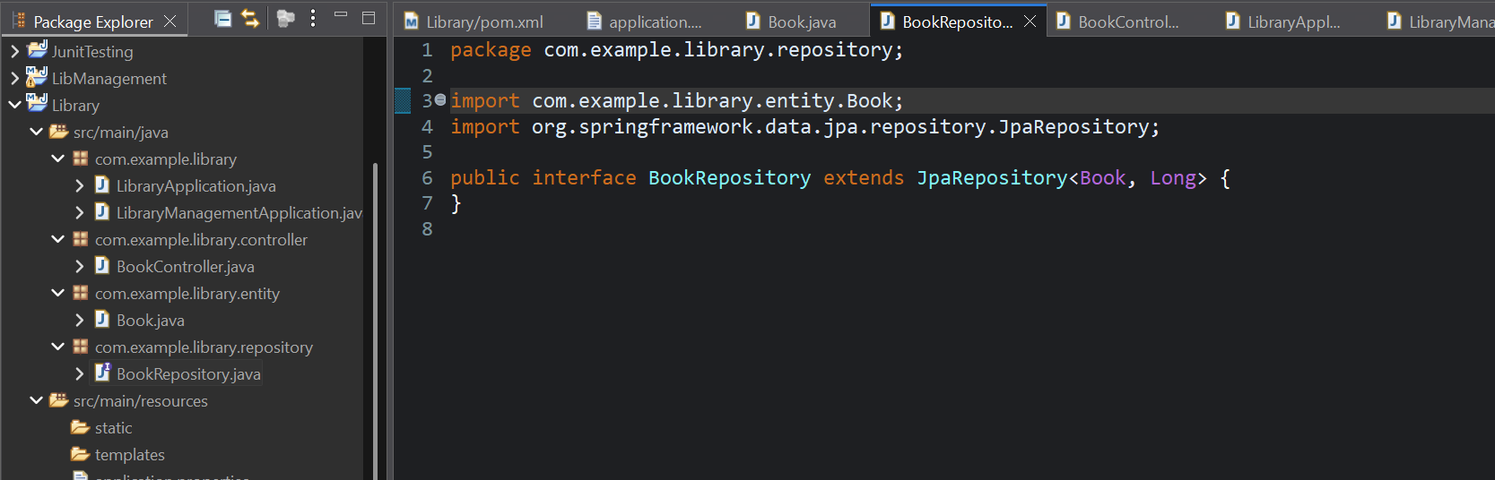

**BookController.java**

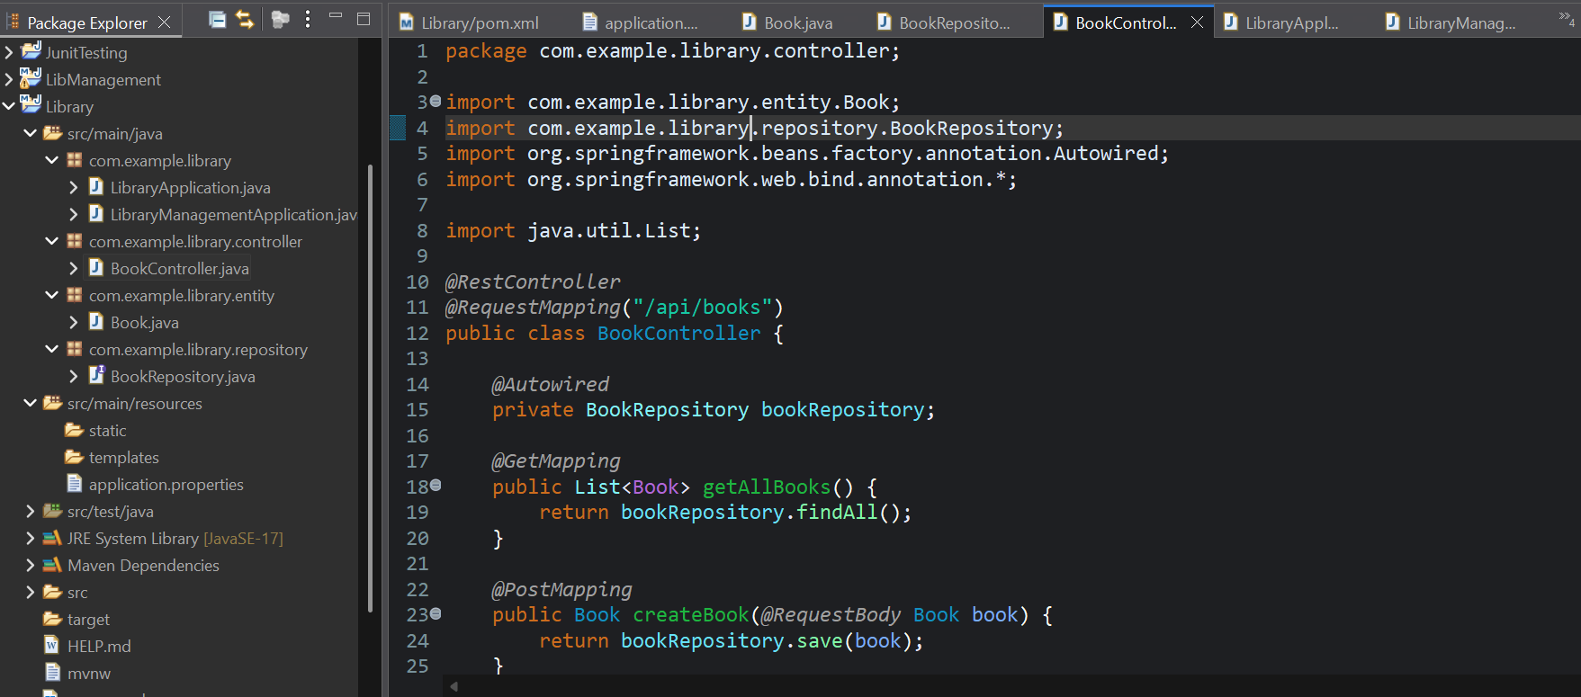 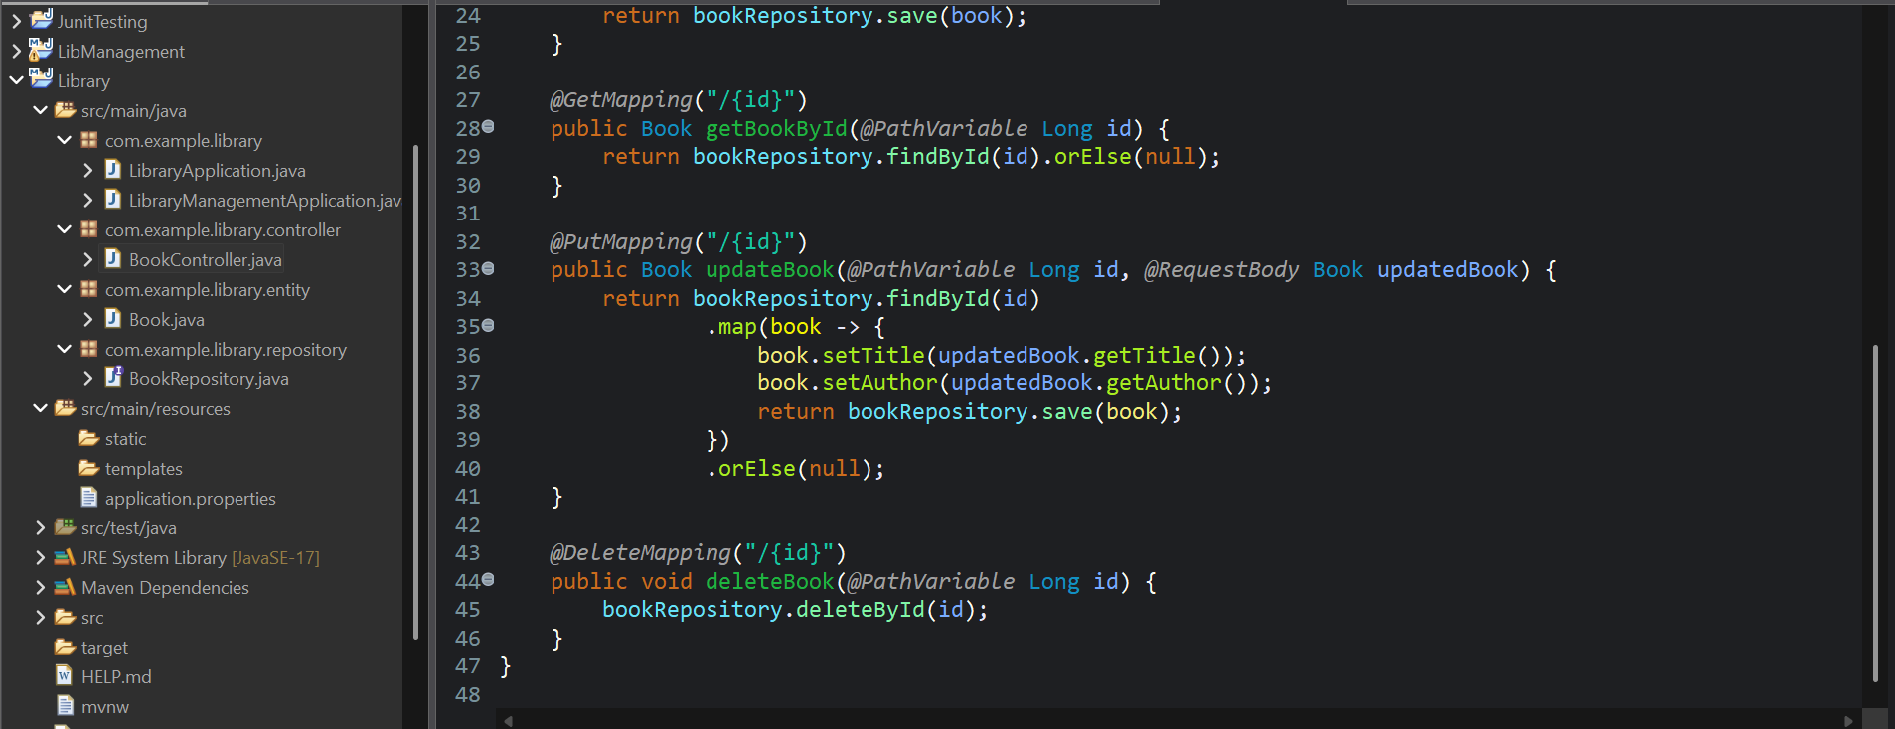

**LibraryManagemenyApplication.java**

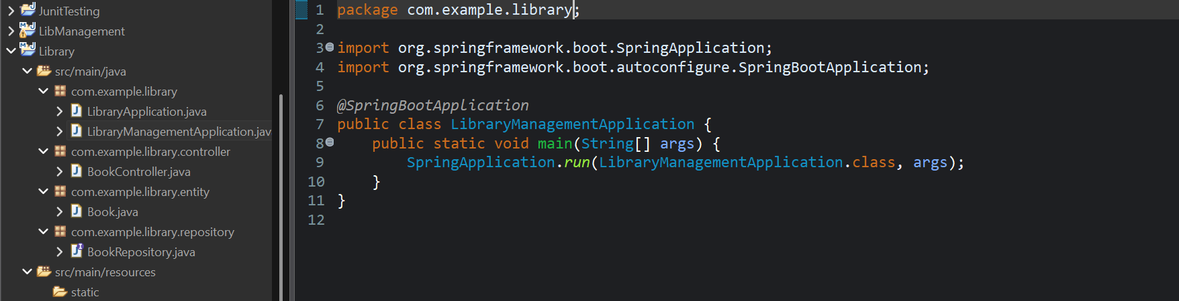

**OUTPUT:**

